Secure Patient Data Platform on Google Cloud

A cost-aware, cloud-native reference solution for small-to-medium clinics
Author: Pranith Jain
Date: 01/10/2025
Scope: Pilot reference deployment for secure storage, access, monitoring, and incident response for simulated PHI.

Executive Summary

Small-to-medium clinics frequently lack budget and dedicated security staff to protect Protected Health Information (PHI). This project delivers a cloud-native reference platform on Google Cloud demonstrating enterprise-grade protections (Customer-Managed Encryption Keys, least-privilege IAM, centralized logging & monitoring, Cloud Armor, DLP) while keeping costs and operational overhead low. Pilot goals: a repeatable IaC deployment, validated detection and playbooks (three simulated incidents), and handover materials for clinic administrators.

Problem Statement

Many small and medium clinics run legacy systems or ad-hoc storage and lack security staff. These environments face high risk from credential compromise, ransomware, and misconfiguration, leading to PHI exposure, regulatory penalties (e.g., HIPAA), financial loss, and loss of patient trust. The platform provides a practical, compliance-ready, and scalable cloud architecture tailored to clinics with limited IT resources.

UN SDG Alignment, Scope & Objectives

Alignment with UN SDG 3:
By protecting patient data and reducing downtime from breaches, the platform helps preserve patient trust and allows health workers to focus on care—supporting UN SDG 3 (Good Health & Well-being), especially Target 3.c (strengthening workforce and systems).

Scope:
In-scope: GCP reference project (VPC, demo web portal, Cloud Storage with CMEK, Workload Identity, custom IAM roles, centralized logging → BigQuery, Cloud Monitoring dashboards & multi-signal alerts, Cloud Armor, Cloud DLP for synthetic data, semi-automated containment, and 3 simulated incidents).
Out-of-scope: live PHI migration (unless approved), formal HIPAA certification, long-term SOC staffing.

SMART Objectives:
- CMEK applied to 100% of demo PHI objects.
- Implement ≥5 least-privilege IAM roles.
- Centralized audit logging and dashboards in BigQuery.
- Multi-signal alerts + semi-automated containment.
- Execute 3 incident simulations and measure MTTD/MTTC.

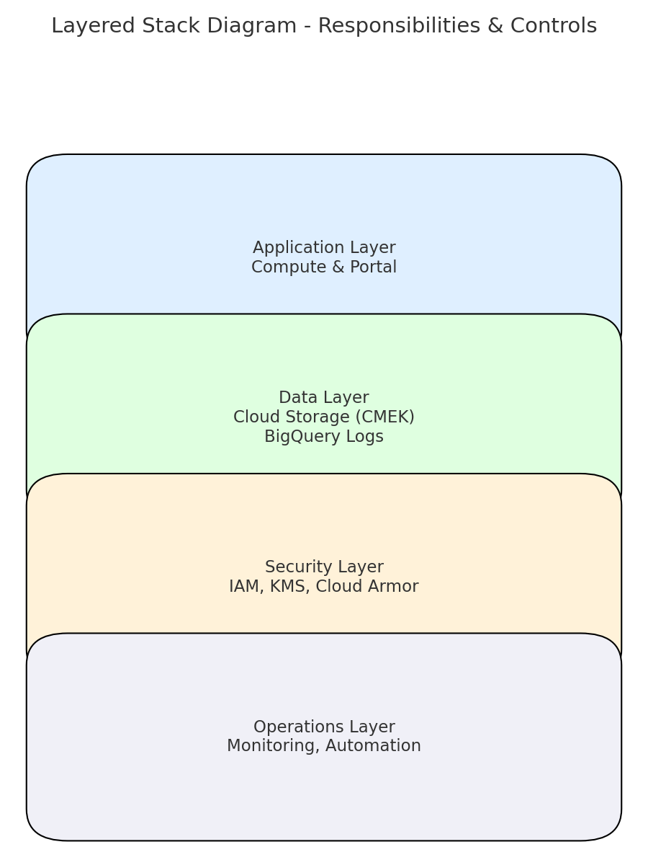

Solution Architecture (Overview)

Core components
Network: VPC with segmented subnets and restrictive firewall rules.
Compute: Demo portal on Compute Engine/GKE using Workload Identity.
Storage & Keys: Cloud Storage for PHI objects + Cloud KMS (CMEK).
Identity: Custom IAM roles, short-lived credentials, enforced MFA, conditional IAM.
Security & Monitoring: Cloud Audit Logs → BigQuery; Cloud Monitoring dashboards; multi-signal alerts; Cloud Armor WAF; Cloud DLP.
Automation: Cloud Functions + Pub/Sub for semi-automated containment (disable keys, apply temporary IAM conditions).
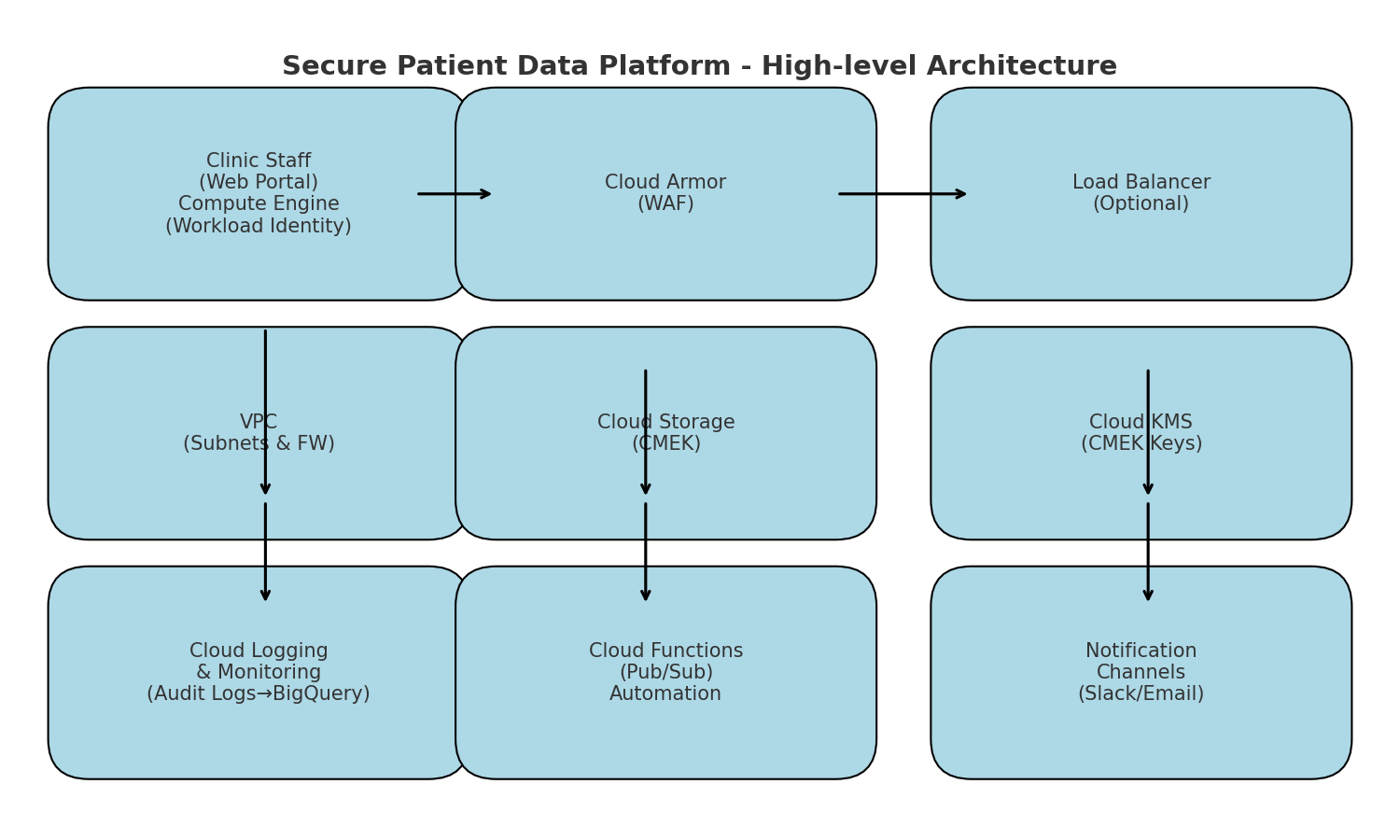

Research & Implementation Plan

Research & Rationale
Sources: IBM/Ponemon (cost of breach), peer-reviewed studies, sector reporting, Reuters, Google Cloud docs. Key findings: healthcare breach costs are highest; attackers increasingly target smaller providers; credential compromise & misconfiguration are leading vectors. These findings shaped an identity-first design, centralized telemetry, multi-signal detection, cost-aware logging, and synthetic-data testing.

Implementation Plan (8–10 weeks)

Week 0: Prep & approvals (billing, permissions, team).
Weeks 1–2: Design & planning (architecture, IAM matrix, HIPAA mapping, test plan).
Weeks 3–5: Build (IaC/Terraform, VPC, demo app, Cloud Storage + CMEK, IAM, Cloud Armor).
Weeks 6–7: Observability & automation (logs → BigQuery, dashboards, multi-signal alerts, Cloud Functions).
Week 8: Validation (3 simulated incidents; tune).
Week 9: Handover (runbook, training, sign-off).

Analysis, Testing & Innovation

Analysis & Insights
Telemetry and simulations identified identity compromise as highest risk. Correlating storage reads + egress spikes + new IPs yields high-fidelity exfiltration signals. BigQuery enables fast investigations; semi-automated containment reduces containment time while preserving audit trails.

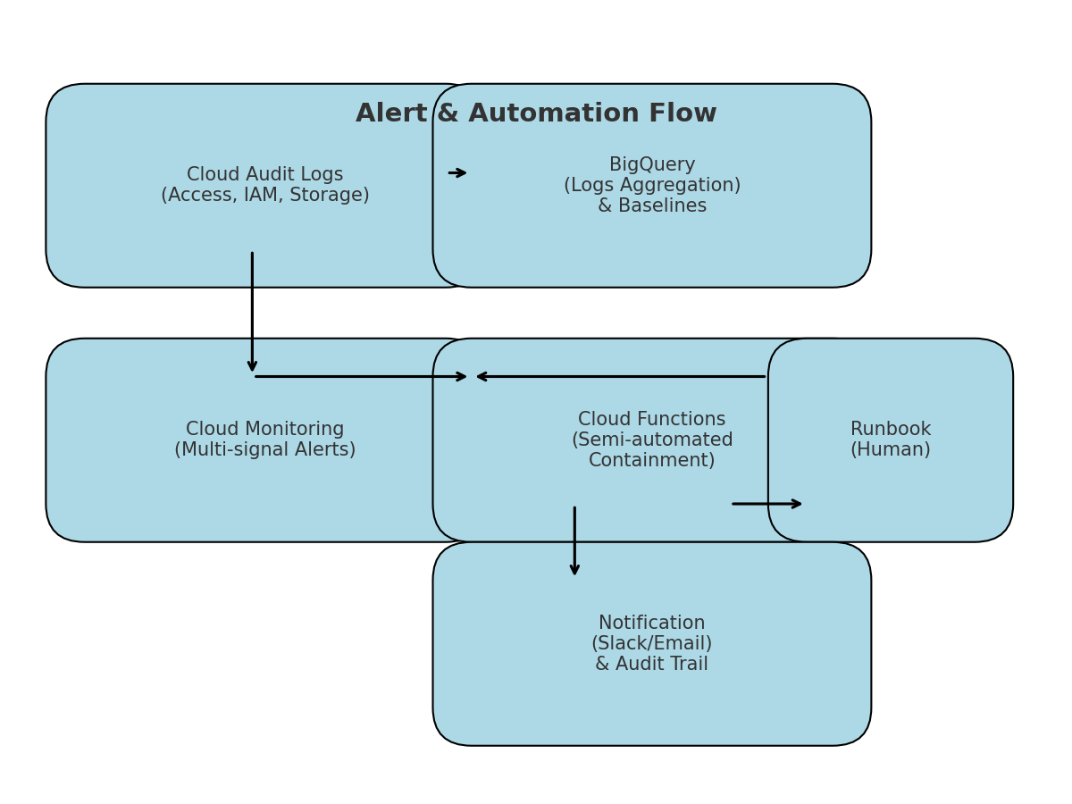

Innovation Highlights
- Practical Zero Trust: short-lived creds, conditional IAM focused on PHI.
- Multi-Signal Detection: correlated alerts across telemetry sources.
- Playbooks-as-Code: semi-automated containment (Cloud Functions + Pub/Sub).
- Synthetic PHI + DLP: realistic testing without live data.
- Policy-as-Code: CI preflight checks to prevent risky changes.

Practicality, Sustainability & Risks

Practicality & Sustainability
Managed GCP services reduce operational overhead and hardware waste. Cost controls (lifecycle rules, sampled logging, partitioned BigQuery) keep recurring costs predictable. IaC makes replication simple; CMEK, audit logs, and DLP provide a compliance-ready foundation.

Top Risks :

Misconfiguration (IAM/public buckets) → mitigation: policy-as-code, CI checks.
Credential compromise → mitigation: MFA, short-lived keys, conditional IAM.
Alert fatigue → mitigation: multi-signal alerts, tuning after baseline.
Accidental real PHI in pilot → mitigation: synthetic-only pilot + DLP checks.
Cost overruns → mitigation: lifecycle rules, budget alerts, tiered monitoring.
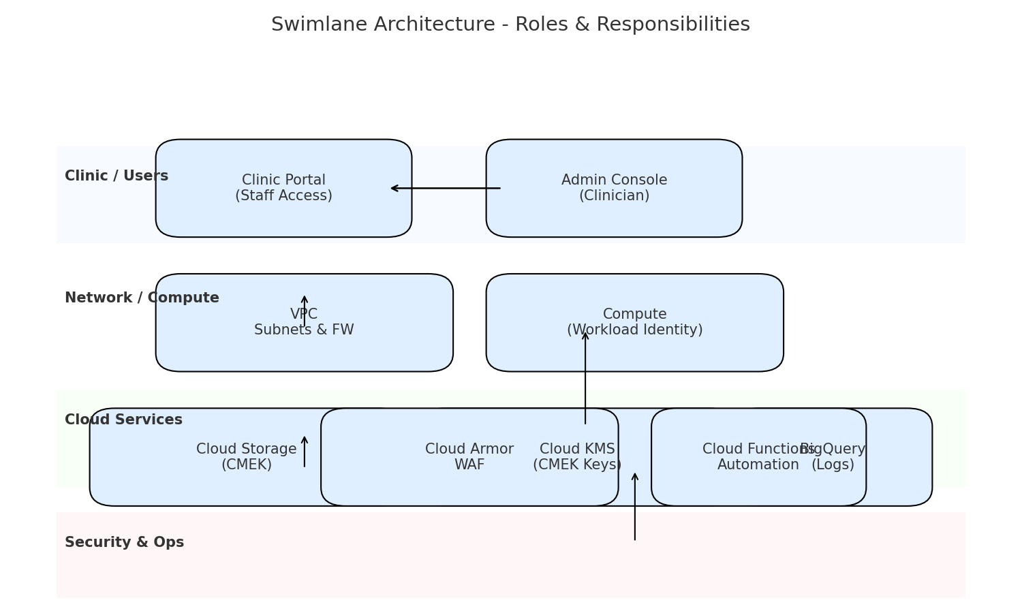

Deliverables, Appendices & Contact

Deliverables

Architecture diagram & implementation runbook.
Terraform repo & policy-as-code checks.
Deployed demo environment with CMEK-enabled storage.
IAM matrix and admin checklist.
Dashboards, multi-signal alerts, automation functions.
3 incident simulation reports and lessons learned.
Training materials and clinic admin sign-off.

